**Section 5: Introduction**

By the end of Capstone, I would like to have worked on and completed the administration part of the DigiClips search engine project as an evaluator role. Since DigiClips is a very large project, our team will only be responsible for the administration part of it. In this part, we will mainly complete the classification management and visualization of the data, and I will mainly play the role of the evaluator in this group work. I will actively follow up on the plans of the team members and assess whether they are feasible and whether there is room for improvement. I'll also be responsible for scheduling and prompting deadlines for each phase to make sure the whole team is on the right track. I will consider the different task goals of the whole project, prevent some important tasks from being missed, and give reasonable suggestions. From a technical point of view, as an evaluator role, I will try to be objective. For example, if a team member wants to make an unrealistic improvement in a certain function due to personal hobbies in the project, I will work with other members to dissuade him and give reasonable reasons for rejection.

**5.1: System architecture**

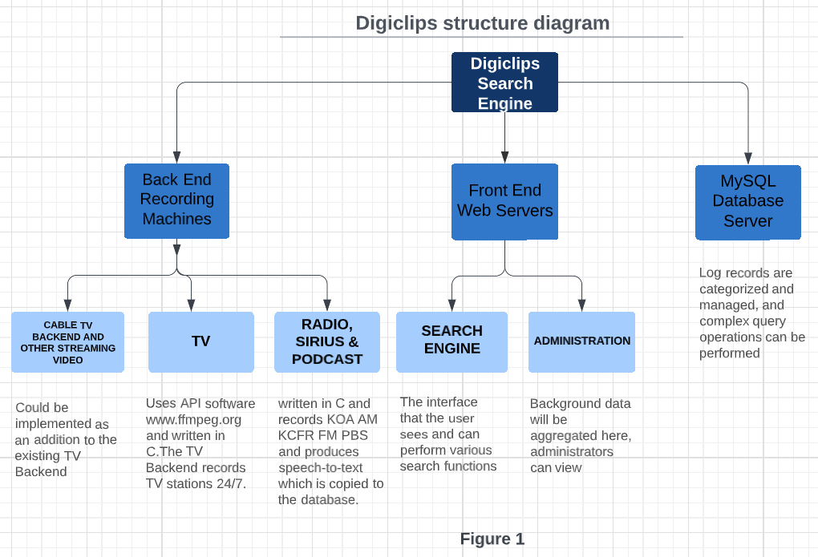**(a) Visualization 1: overall conceptual model**

**(b) Visualization 2: administration model**

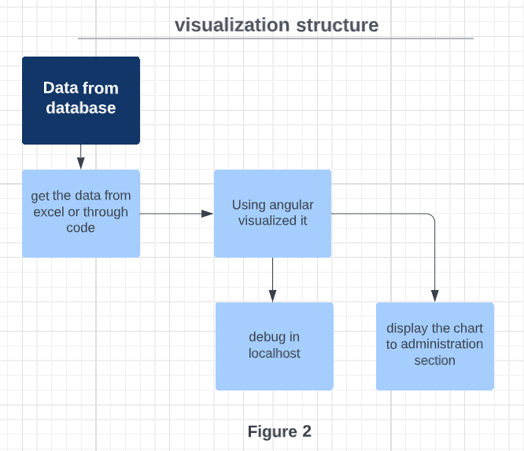

First step, we use VPN to link to the database, this can allow us to get user data and accurately track down some bugs. We will classify and manage the obtained data for the convenience of administrators to view.

Second step, “using angular visualized it” refers to the code file that converts the data into a chart. Similar to python and other languages, Angular also has the ability to visualize data. When we link to the database, we can get the data we need and start processing the next step. With several Angular files, we can successfully compile a simple localhost website and record all the valid username and password, and send them back to our backend.

Visualizations fall into many different types of charts, including but not limited to pie charts, line charts, histograms, and more. After processing the code in the previous step, we can export these charts in a file and are ready for the next step.

When we connect to the VPN, we have a localhost web page where we can debug and perform various tests. When our tests are done, we will send the charts and other data back to the administration part.

Our team has regular meetings every Tuesday and Friday where we talk about our individual tasks. I will compare the schedule we have planned together, and point out the progress that should be accelerated, or the function that should be modified. For example, our task this week is to modify the IP address displayed on excel according to the code. If it has not been completed this Friday, I will consider adding a meeting to complete it together. If the delivery cannot be made within the stipulated time, I will consider modifying the schedule reasonably and report the situation to the sponsors.

**5.2: User Stories:**

User Story 1: “As a project manager, I need to receive the minimum delivery product within the stipulated time, so that we don't spend too much time on the wrong direction.”

User Story 2: “As an evaluator role in corporate team, I need to quickly find accurate charts for monitoring data, so that I don't waste too much time on features that aren't necessary.”

User Story 3: “As a project partner, I need to see that you are planning our every small goal reasonably, so that we can keep in the same direction without talking too much about extra features.”

**5.3: Iteration Plan and Estimates**

**In this form, my name is highlighted in orange.**

